Marie Kelling
 | Paste in your answers for each step below in this column.
1 | Phase 1 EER Diagram | 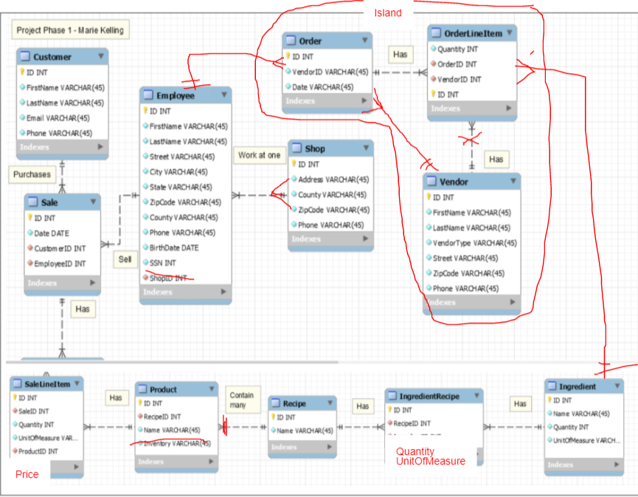
2 | Phase 1 EER Diagram | 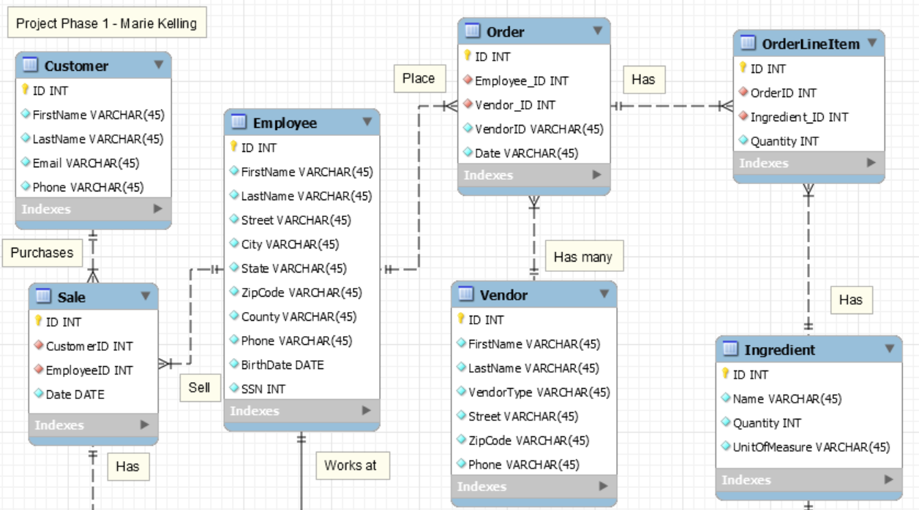  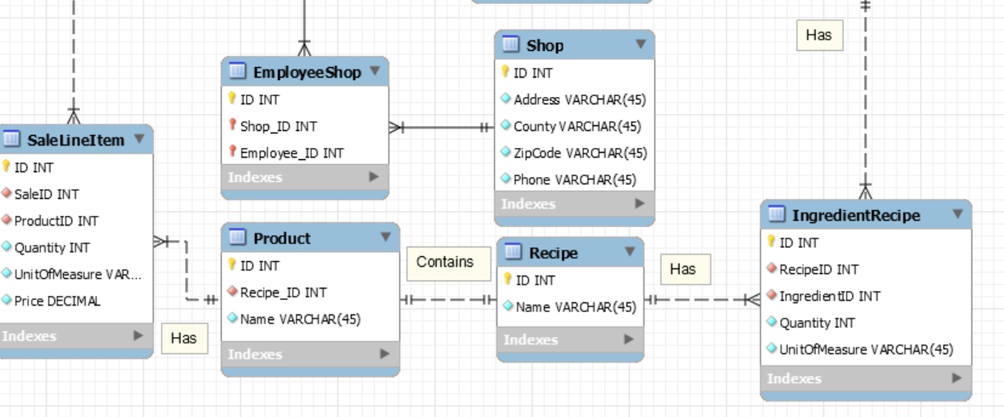
3 | Crayon Definition
  Entity Name | Crayon Definition
  Customer | The Customer table contains records of each customer’s personal information
  Employee | The Employee table keeps track of each employee’s personal information and the shop they’re associated with
  Sale | The Sale table keeps track of the employee who made the sale and the shop the sale was made at
  Shop | The Shop table contains records of each shops location information
  Order | The Order table keeps track of the vendor and the date the order was placed
  Vendor | The Vendor table contains records of each vendor’s location and personal information
  Recipe | The Recipe table keeps track of the recipes used to make the shop’s products
  Product | The Product table contains records of the products sold to customers
  Ingredient | The Ingredient table contains records for the ingredients needed for the shop’s recipes
  Ingredient-Recipe | Implements the many-to-many relationship between Ingredients and Recipes
  Sale-Line-Item | Implements the many-to-many relationship between Sales and Products
  Order-Line-Item | Implements the many-to-many relationship between Orders and Vendors
4 | Tree View Screenshot with columns expanded | 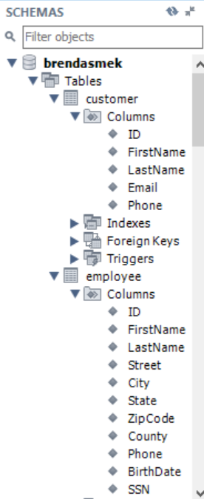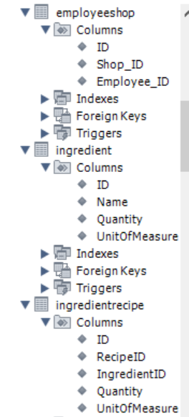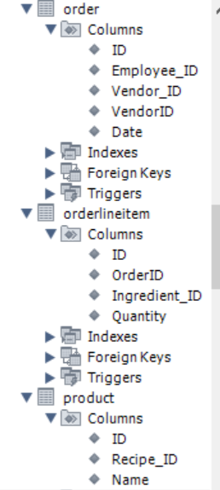  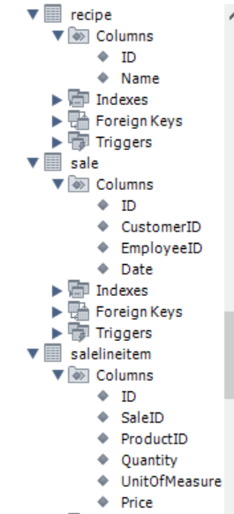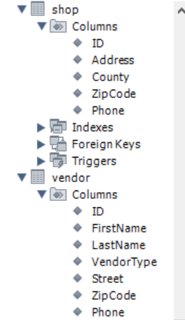
5 | SQL that adds two records in each table. | 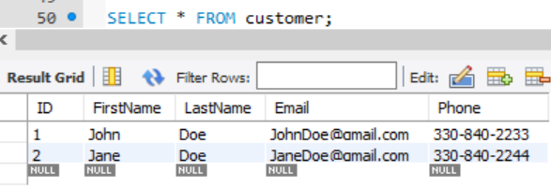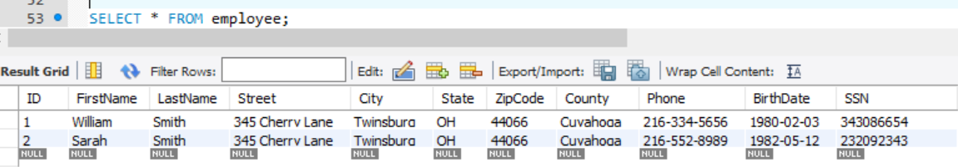  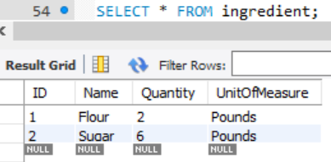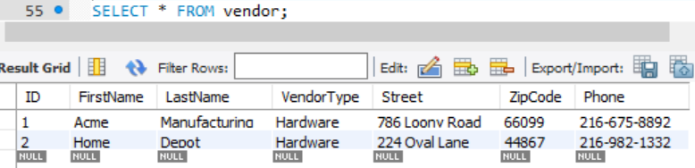  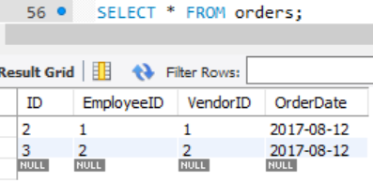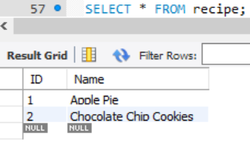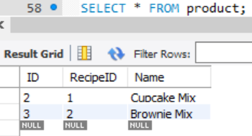  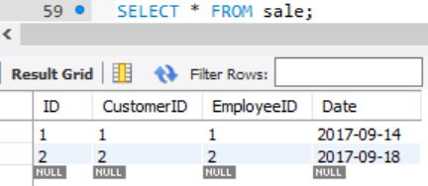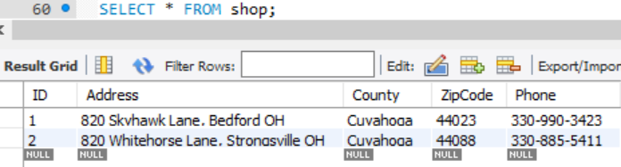
6 | Describe any changes. | I definitely think I need to organize my tables and their information better, but other than that, my record insertion went very smoothly.

